**CPT205 Computer Graphics (2020-21)**

**Assessment 3 – Discussion Questions and 3D Modelling Project**

**Xianyao Li**

**1824764**

**ICS**

**January 3, 2021**

**PART I. Discussion Questions**

**Question 1.** Briefly describe the graphics pipeline, identify pipeline bottlenecks, and discuss possible ways to tackle the bottlenecks for enhancing the performance from both software (e.g. algorithms) and hardware perspectives.

**Q1 Answer**:

Graphics pipeline

Graphics pipeline is constituted by several steps . Now, the fixed stage with graphics pipelines of embedded systems are popularly trends. This technology often be provided by different companies, in order to manage the graphics pipeline from different vendors, a standard interface should be applied.Such as, DirectX and OpenGL[1].In this case, we use one embedded system standard of OpenGL , which is OpenGL ES 1.1. because many GPU manufacturers support this specification.

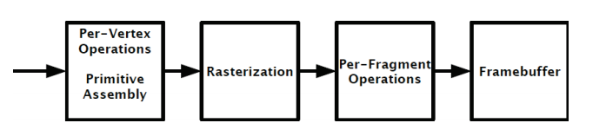

Fig. 1: OpenGL ES 1.1 pipeline [2]

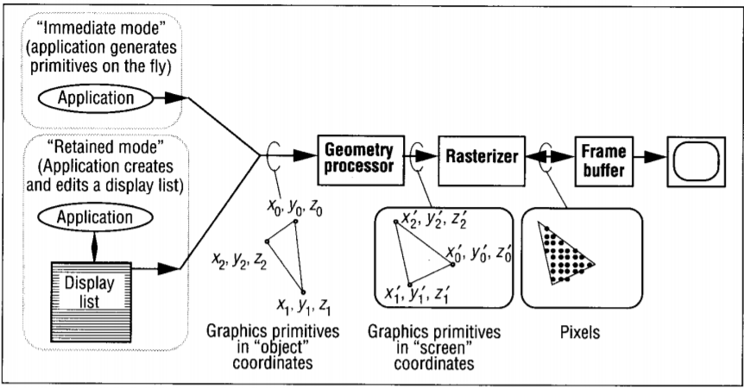

Fig. 2: The graphics pipeline pipeline [3]

Figure 1 is the steps of the OpenGL ES 1.1 standard.Figure 2 is the graphics pipeline pipeline .The pipeline includes the following functions.Vertex operations is a collection of information, including location in space, vertex color, normals, texture coordinates, and so on.The input in this stage is independent vertex information, and the fixed function pipeline usually performs the following work in the three stages . First ,vertex position transformation . Second, calculate illumination for each vertex. Third, generation and transformation of texture coordinates.Primitive assembly is a phase that input vertex and connection information derived from the vertex operations .Connection information tells pipeline vertices how to form primitives (triangles, quadrilaterals, etc.).This stage is also responsible for the cropping of view frustum and the back culling.Rasterization determines the pixel positions of fragments and primitions.A fragment is a piece of data used to update a pixel at a specific location in the Frame Buffer.In addition to the color, a fragment contains properties such as normals and texture coordinates, which are used to calculate the new pixel color value.The outputs of these two phases include the position of the segments in the frame cache and the interpolation of each segment with the information calculated during the vertex transformation phase.This phase uses the data calculated in the vertex transformation phase, combined with the connection information to calculate the pieces of data.For example, each vertex contains a transformed position when composed of primitives, which can be used to calculate the segment position of the primitives.Another is using color, If each vertex of a polygon has its own color value, then the color value of the inner fragment of the polygon is the color interpolation for each vertex.Fragment operation include fragment Texturing and Coloring .The input at this stage is interpolated pieces of information.The texture coordinates and a color value have been calculated by interpolation in the previous stage, and the color can be used to combine with the texture elements in this stage.In addition, this stage can also be atomized treatment.Usually the final output is the color value of the fragment and the depth information.In frame buffer ,each unit of the buffer corresponds to a pixel on the screen[3].

Pipeline bottlenecks

By analyzing the pipeline, we can find the module with bottleneck. Limitation of logical computing power of CPU itself.Limit of CPU to GPU memory AGP transfer capacity.Limit of GPU memory transfer bandwidth to GPU buffer.Limit of GPU buffer internal processing capacity.Memory limit.GPU memory is limit.One above problem with interactive graphics systems is the bandwidth bottleneck between the rasterizer for any unit pixel point in the scene primitive and the frame buffer which the storage system stores pixel values [3].The system usually uses the Z-Buffer algorithm to determine the visible primitives at each pixel.The forward difference is usually used to calculate the z value, so that it only takes one simple calculation to get each primitive per pixel.For each pixel in each primitive, the system must read the z value from the frame color value and return it to the frame buffer.If we assume that the average size of the quadrilateral is 50 pixels, that three-quarters of the pixels are initially visible, and that all three color components can be written together, then we need about 125 million frame buffer accesses per second.Therefore, frame buffers that support interaction with high-quality, anti-aliasing images requires moderate storage space, but require very high access rates.There exist two challenge.

Tackle the bottlenecks

Hardware optimization, improve CPU memory and GPU memory.

Software optimization.Reduce unnecessary waiting caused by thread locking.CPU locks a resource and waits for GPU to render. In this case, the common practice is to wait for GPU to render, during which the CPU is often Idle. It is suggested to assign other tasks to the CPU at this time, such as basic preparation for the next resource or logical processing.Reduce or even distribute CPU pressure, which may be mainly in the following aspects: AI, IO, network, complex logic, these parts can be tested for CPU bottlenecks to determine the direction of optimization.Optimize the AGP transmission bottleneck. When too much data is transferred from CPU memory to GPU video memory via AGP8X, you can choose the following optimization method.Reduce the number of vertices, reduce the number of dynamic vertices, using Vertex Shader animation instead.Determine the appropriate frame buffer, texture buffer, and static vertex buffer sizes according to the hardware configuration properties.Avoid the use of unordered or irregular data transfers, where the number of vertices should be integer multiples of 32, ensuring that the vertices are ordered[3].In the future, the development and innovation of hardware continuously promote the generation and iterative development of new graphics software technologies and applications.In this process, graphics is constantly combining the latest research results of computer vision, optics, signal processing and machine learning to solve the research problems in graphics.Through the investigation found that the following hardware will usher in new developments and bring revolutionary advances in graphics technology and applications.3D display,which provide high resolution, high dynamic range of full 3D display.Depth camera,which provides high resolution, high frame rate, low power consumption, low noise depth cameras to match existing color cameras.3d printer,which provide simultaneous support for a variety of printing materials, high precision, low price.All these technologies need to rely on high-efficiency algorithms and GPU, so improving the efficiency of algorithms and GPU is the future trend.

**Question 2.** Discuss applications of computer graphics incorporating artificial intelligence. This should cover techniques, key issues and possible solutions with directions for future development.

**Q2 Answer:**

Applications of computer graphics incorporating artificial intelligence

Computer vision is a branch of graphics, the study of how to let computers recognize real life images.The technology uses cameras and computers to identify, track and measure targets.The processing of the resulting data to make the image more suitable for human vision or other devices.The introduction of deep learning has led to the development of possible lines for computer recognition of graphs.After the computer recognizes the information of the graph, a set of data is obtained and analyzed, and the result is submitted to manual review, and finally the result is marked as similar to the expected result.After a number of computer studies, the algorithm can output an accurate result.Thus, the combination of computer graphics and artificial intelligence supports the computer to recognize the road information and automatically map an area.In a factory, an automatic route recognition robot can efficiently move around the area.According to the survey, 1.8 billion photos are uploaded to the Internet every day. Each photo is valuable information, including people, places and times. Graphics technology can be used to separate information and categorize photos.Artificial intelligence and computer graphics complement each other, so that machines can automatically understand the content of images is a major challenge for the scientific community, and also the basis for achieving strong artificial intelligence.

In the future, commercial applications and algorithmic advances for visual content are converging[4].For example, in the field of logistics, computer vision can recognize the facial expressions of truck drivers, judges whether the driver is tired according to different states, and make corresponding measures. This application has greatly reduced the probability of truck accidents[5].

Techniques

The basics of computer vision include basic theory of vision, neurophysiology, cognitive science, chromaticity, and optics.The bottom processing includes image processing, spatial image processing, frequency domain image processing and image feature extraction.The middle processing includes image segmentation, camera calibration, depth estimation and motion estimation.High level processing includes 3D reconstruction and target recognition.Among them, the underlying processing is responsible for feature extraction and region segmentation, based on contour, texture and color.The middle layer is responsible for modeling and pattern representation, abstracting models based on various objects.High-level processing is responsible for describing and understanding the structural knowledge based on scenery.The current research on computer vision is at a plateau, which means that there are preliminary technical implementations.For example, the development of input devices, including imaging devices and digital devices.Imaging equipment refers to the detection imaging of the surrounding scene or object by optical camera or infrared, laser, ultrasonic, X-ray, to obtain a two-dimensional or three-dimensional digital image of the scene or object.A large number of image processing techniques and algorithms are used to preprocess the input original image[6].

Key issues and possible solutions

Software issues

First of all, the generation of image ambiguity leads to the projection of 3d scene into 2D image, and the information of depth and invisible part is lost.As a result, the same image can be generated when 3d objects of different shapes are projected onto the image plane.In addition, the image of the same object obtained from different angles can be different.Secondly, due to many factors in the scene, including lighting, object shape, surface color, camera and spatial relation changes, which exist an impact on the algorithm.Finally, each image that needs to be processed contains a large amount of data, such as grayscale image, color image and depth image.The amount of information in these data is huge, which requires a lot of storage space and is not easy to be processed quickly.Next are some possible solutions,Image ambiguity can be resolved by combining images of multiple 3D scenes into one image with feature point data.After obtaining the image information, artificial intelligence algorithm can be used to filter out the impurity light waves in the environment to solve the problems caused by environmental factors.

Hardware issues

The reading and analysis of computer vision needs to consume a large amount of GPU resources as the basis. Considering the current GPU performance, it is impossible to complete a large amount of processing work.So the possible solution is to develop high-performance GPU, or to specialize in framework-specific hardware for computer vision.

Future development

Graphics and artificial intelligence depend on each other and develop alternately.

In the future driverless technology, image recognition technology needs to rely on a lot of computer vision foundation.Developing an efficient image recognition system is the scientific community's next challenge.

**References:**

**[1]O. Sicoe and M. Popa, "Comparison metrics for the output of a mixed fixed point and floating point graphics pipeline," 2017 25th Telecommunication Forum (TELFOR), Belgrade, 2017, pp. 1-4, doi: 10.1109/TELFOR.2017.8249424.**

**[2]T. K. G. Inc, “Opengl ES Common/Common-Lite Profifile Specifification,” https://www.khronos.org/registry/gles/#specs11.**

**[3]J. Poulton, J. Eyles, S. Molnar and H. Fuchs, "Breaking the frame-buffer bottleneck with logic-enhanced memories," in IEEE Computer Graphics and Applications, vol. 12, no. 6, pp. 65-74, Nov. 1992, doi: 10.1109/38.163626.**

**[4]A. Jaimes, "Computer Vision Startups Tackle AI," in IEEE MultiMedia, vol. 23, no. 4, pp. 94-96, Oct.-Dec. 2016, doi: 10.1109/MMUL.2016.62.**

**[5]G. Zhao and A. Han, "Method of Detecting Logistics Driver's Fatigue State Based on Computer Vision," 2015 International Conference on Computer Science and Applications (CSA), Wuhan, 2015, pp. 60-63, doi: 10.1109/CSA.2015.70.**

**[6]B. Zhang, "Computer vision vs. human vision," 9th IEEE International Conference on Cognitive Informatics (ICCI'10), Beijing, 2010, pp. 3-3, doi: 10.1109/COGINF.2010.5599750.**

**PART II. 3D Modelling Project**

**Written Report** [You may have headings/sections and sub-headings/subsections where you would like to.]

**Design and features**

This is a scene in sea-view room. There is a table near the window, the room has a interaction rotation chair, interactive zooming teapot, bookcase, books, interactive cabinet, bed, rotating lamp, a dozen black stone at the edge of room, a interactive system of the earth and moon, and four painting through texture mapping.Among them, there are the following graphic techniques used:

1.The geometric primitives (This technique is used to create geometric shapes)：Solid cube, circle, straight line, rectangle,Solid Cylinder. such as gluSphere(quadricObj, 80, 80, 80);glutSolidCube(500);glutSolidCylinder(40, 400, 10, 10);glutSolidCube(500);

2.Geometric Transformations (This technique is often used to transform a cube into other shapes, scale or move it around).such as :glPushMatrix();glTranslatef(4500, 300.0, 0);glScalef(20, 0.1, 1);glRotatef(chair, 0, 1, 0);glPopMatrix();

3.Viewing and Projection (This technique is used to set the Angle of view).Such as:gluLookAt(fltX0 + 2000, 1000, fltZ0, fltX0 + fltY0 - 7000, fltYRef, fltZ0 + fltY0, fltXUp, fltYUp, fltZUp);

4.3D Modelling (This technique can be used to make 3d models, also can combine multiple models into one).

Use solid modelling such as : glutSolidCylinder(40, 400, 10, 10);

We can combine 3D modelling and geometric transformations to built a bed :

lPushMatrix();glTranslatef(-2000.0, 0.0, 2400);glPushMatrix();glScalef(1, 2, 0.1);glColor3f(139 / 255, 115 / 255, 85 / 255);glutSolidCube(500);glPopMatrix();glPushMatrix();glTranslatef(0.0, 0.0, -650);glPushMatrix();glScalef(1, 1, 2.5);glColor3f(0.6, 0.2, 0.0);glutSolidCube(500);glPopMatrix();glPopMatrix();glPushMatrix();glTranslatef(0.0, 300, -90);glPushMatrix();glScalef(1, 0.2, 0.2);glColor3f(0.2, 0.4, 0.5);glutSolidCube(500);glPopMatrix();glPopMatrix();glPushMatrix();glTranslatef(0.0, 300, -700);glPushMatrix();glScalef(1, 0.15, 2);glColor3f(0.5, 0.5, 0.5);glutSolidCube(500);glPopMatrix();glPopMatrix();glPopMatrix();

5.Hierarchical Modelling(This technique gives objects a sense of hierarchy). Use linear modelling we can made a bookcase and book. Such as:for (int i = 0;i < 10;i = i + 2) {

glPushMatrix();glTranslatef(0 * i, 0, 0);glColor3f(0.1, 0.1, 0.0);glutWireCube(500);glutSolidCube(500);glPopMatrix();glPushMatrix();glTranslatef(500 * i, 0, 0);glColor3f(0.1, 0.4, 0.0);glutWireCube(500);glutSolidCube(500);glPopMatrix();glPushMatrix();glTranslatef(1000 * i, 0, 0);glColor3f(0.3, 0.5, 0.0);glutWireCube(500);glutSolidCube(500);glPopMatrix();}

Use articulated model to made a activity robot.//=====people=====glPushMatrix();glTranslatef(-700, -200, people1 + 600);glPushMatrix();glTranslatef(0, 900, 0);glPushMatrix();glScalef(0.8, 1, 0.8);glColor3f(1, 0.8, 0);glutSolidCube(100);glPopMatrix();glPopMatrix();//hairglPushMatrix();glTranslatef(0, 960, 0);glPushMatrix();glScalef(0.8, 0.2, 0.8);glColor3f(0, 0, 0);glutSolidCube(100);glPopMatrix();glPopMatrix();//bodyglPushMatrix();glTranslatef(0, 675, 0);glPushMatrix();glScalef(2.5, 3.5, 0.8);glColor3f(0, 0, 1);glutSolidCube(100);glPopMatrix();glPopMatrix()//armglPushMatrix();glTranslatef(155, 775, 0);

glPushMatrix();glRotatef(peopleangle, 1, 0, 0);glPushMatrix();glScalef(0.625, 1.5, 0.8);glColor3f(0, 0, 1);glutSolidCube(100);glPopMatrix();glPushMatrix();glTranslatef(0, -160, 0);glPushMatrix();glScalef(0.625, 1.75, 0.8);glColor3f(1, 0.8, 0);glutSolidCube(100);glPopMatrix();glPopMatrix();glPopMatrix();glPopMatrix();glPushMatrix();glTranslatef(-155, 775, 0);glPushMatrix();glRotatef(-peopleangle, 1, 0, 0);glPushMatrix();glScalef(0.625, 1.5, 0.8);glColor3f(0, 0, 1);glutSolidCube(100);glPopMatrix();glPushMatrix();glTranslatef(0, -160, 0);glPushMatrix();glScalef(0.625, 1.75, 0.8);glColor3f(1, 0.8, 0);glutSolidCube(100);glPopMatrix();glPopMatrix();glPopMatrix();glPopMatrix();

//leg glPushMatrix();glTranslatef(77.5, 475, 0);glPushMatrix();glRotatef(-peopleangle / 2, 1, 0, 0);glPushMatrix();glScalef(0.625, 1.5, 0.8);glColor3f(0, 1, 1);glutSolidCube(100);glPopMatrix();glPushMatrix();glTranslatef(0, -160, 0);glPushMatrix();glScalef(0.625, 1.75, 0.8);glColor3f(1, 0.8, 0.1);glutSolidCube(100);glPopMatrix();glPopMatrix();glPopMatrix();glPopMatrix();glPushMatrix();glTranslatef(-77.5, 475, 0);glPushMatrix();glRotatef(peopleangle / 2, 1, 0, 0);glPushMatrix();glScalef(0.625, 1.5, 0.8);glColor3f(0, 1, 1);glutSolidCube(100);glPopMatrix();glPushMatrix();glTranslatef(0, -160, 0);glPushMatrix();glScalef(0.625, 1.75, 0.8);glColor3f(1, 0.8, 0.1);glutSolidCube(100);glPopMatrix();glPopMatrix();glPopMatrix();glPopMatrix();glPopMatrix();

6.Lighting and Materials(This technique allows you to create virtual geometries that work better with light and shadow) : Use ambient light,diffuse reflectance,specular reflectance . Such as:GLfloat light1_position[4] = { -1,1,-1,0 };GLfloat light2_position[4] = { 1,-1,1,0 };GLfloat ambientlight[4] = { 0.5,0.5,0.5,0.5 };GLfloat diffuselight[4] = { 0.6,0.6,0.5,0.5 };GLfloat specularlight[4] = { 0.5,0.5,0.5,0.5 };

GLfloat mat_ambient[4] = { 0.0,0.0,0.0,1.0 };GLfloat mat_diffuse[4] = { 0.6,0.6,0.6,0.6 };GLfloat mat_specular[4] = { 0.2,0.2,0.2,0.8 };GLfloat mat_shininess[1] = { 0.0 };

made a polygonal shading such as :glutSolidRhombicDodecahedron(); Use multiple lights to create a better lighting scene such as :light1_position[4] = { -1,1,-1,0 }; light2_position[4] = { 1,-1,1,0 };

7.Texture Mapping(Map the picture information geometrically) :We can use this technique to map the portrait into the scene.Such as:glBindTexture(GL_TEXTURE_2D, texture[0]);glBegin(GL_QUADS);glTexCoord2f(0.0, 0.0); glVertex3f(-2000, 1000, -2480);glTexCoord2f(0.0, 1.0); glVertex3f(-2000, 2400, -2480);glTexCoord2f(1.0, 1.0); glVertex3f(-1100, 2400, -2480.0);glTexCoord2f(1.0, 0.0); glVertex3f(-1100, 1000, -2480.0);glEnd();

8.Hidden-Surface Removal .Such as :glEnable(GL_DEPTH_TEST);glBindTexture(GL_TEXTURE_2D, texture[1]);glBegin(GL_QUADS);glTexCoord2f(0.0, 0.0); glVertex3f(-2500, 0, 2500);glTexCoord2f(0.0, 1.0); glVertex3f(-2500, 2500, 2500);glTexCoord2f(1.0, 1.0); glVertex3f(-2500, 2500, -2500.0);glTexCoord2f(1.0, 0.0); glVertex3f(-2500, 0, -2500.0);glBegin(GL_QUADS);glColor3f(1, 0.9, 0.87);glVertex3f(-2400, 300, 2500);glVertex3f(-2400, 300, -2500);glVertex3f(-2400, 0, -2500.0);glVertex3f(-2400, 0, 2500.0);

**Interactive commands:**

'e' or 'E' moves the view to the right,

'q' or 'Q' moves the view to the left,

'a' or 'A' moves camera to the left,

'd' or 'D' moves camera to the right,

's' or 'S' moves camera backward ,

'w' or 'W' moves camera forward,

'v' or 'V' opens the chair rotation,

'c' or 'C' closes the chair rotation,

'o' or 'O opens the teapot zooming,

'p' or 'P' closes the teapot rotation,

'h' or 'H' opens the cabinet drawer,

'b' or 'B' closes the cabinet drawer,

'g' or 'G' opens the character movement,

't' or 'T' closes the character movement.

'left mouse button' opens the planetary system,

'right mouse button' closes the planetary system.

**Screenshots:**

start [the](D:/Dict/8.9.5.0/resultui/html/index.html" \l "/javascript:;) [right](D:/Dict/8.9.5.0/resultui/html/index.html" \l "/javascript:;) [mouse](D:/Dict/8.9.5.0/resultui/html/index.html" \l "/javascript:;) [button](D:/Dict/8.9.5.0/resultui/html/index.html" \l "/javascript:;)

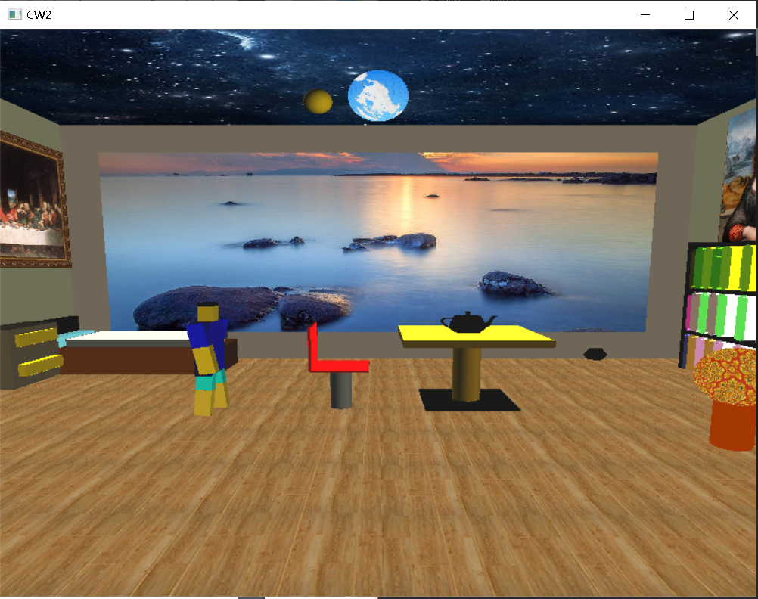 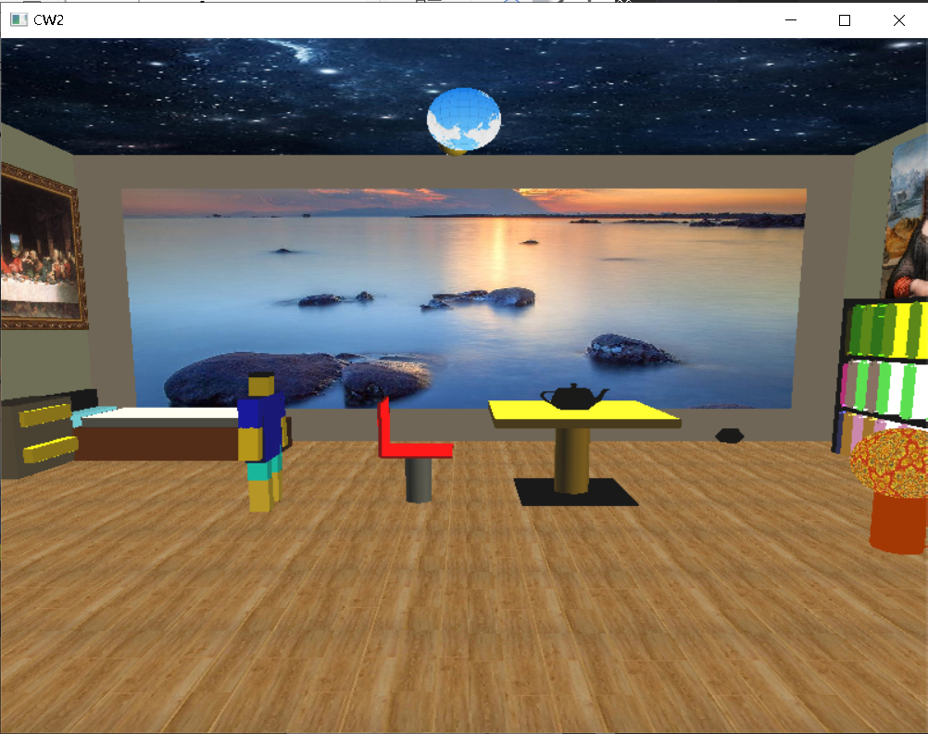

press w or W press a or A

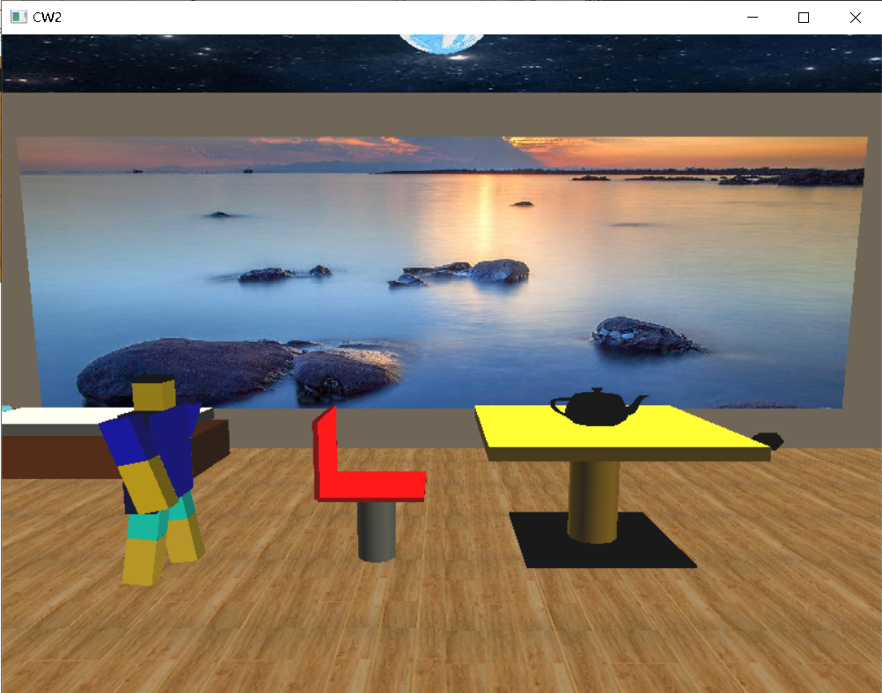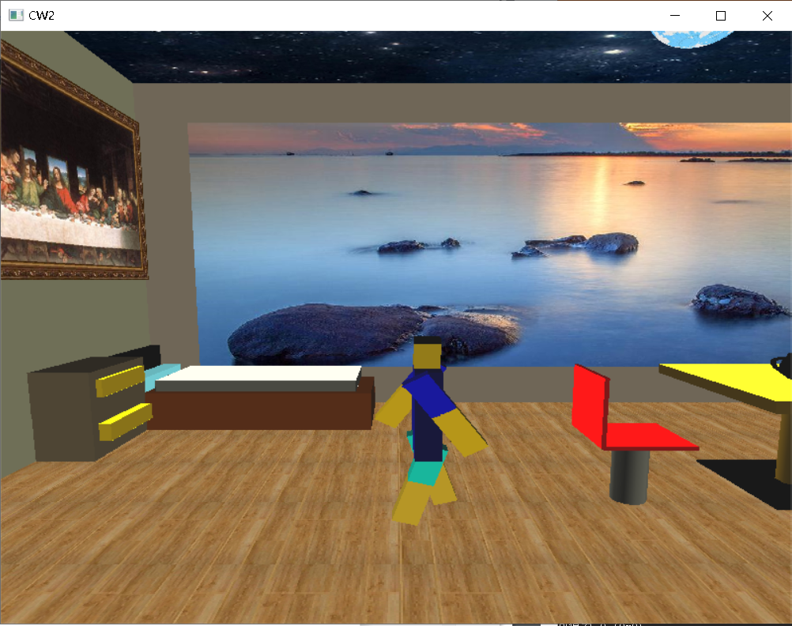

press d or D press q or Q

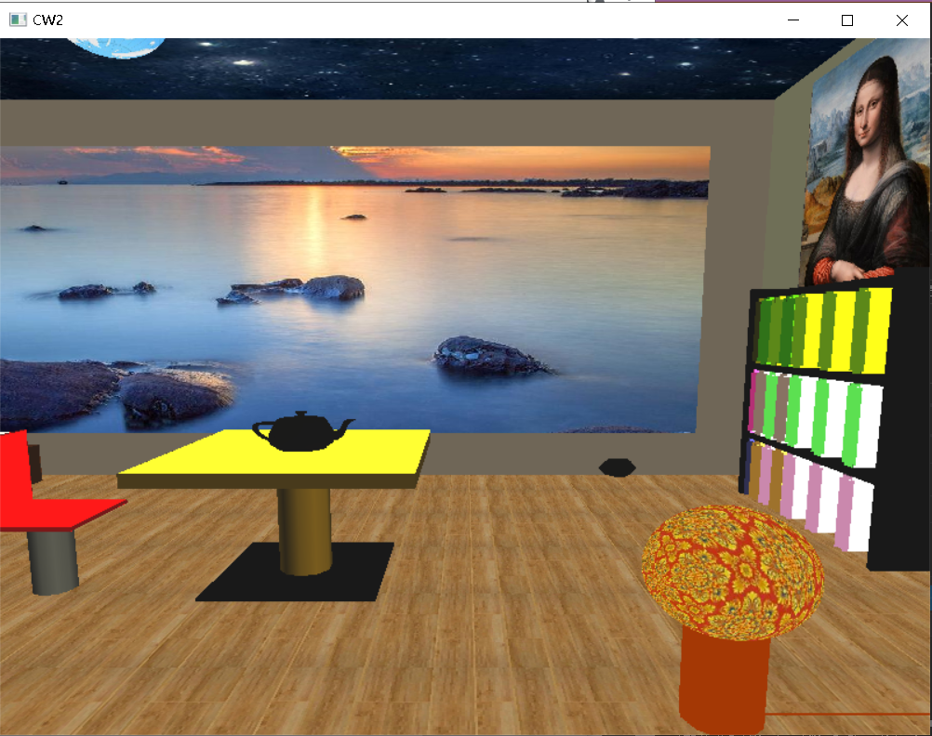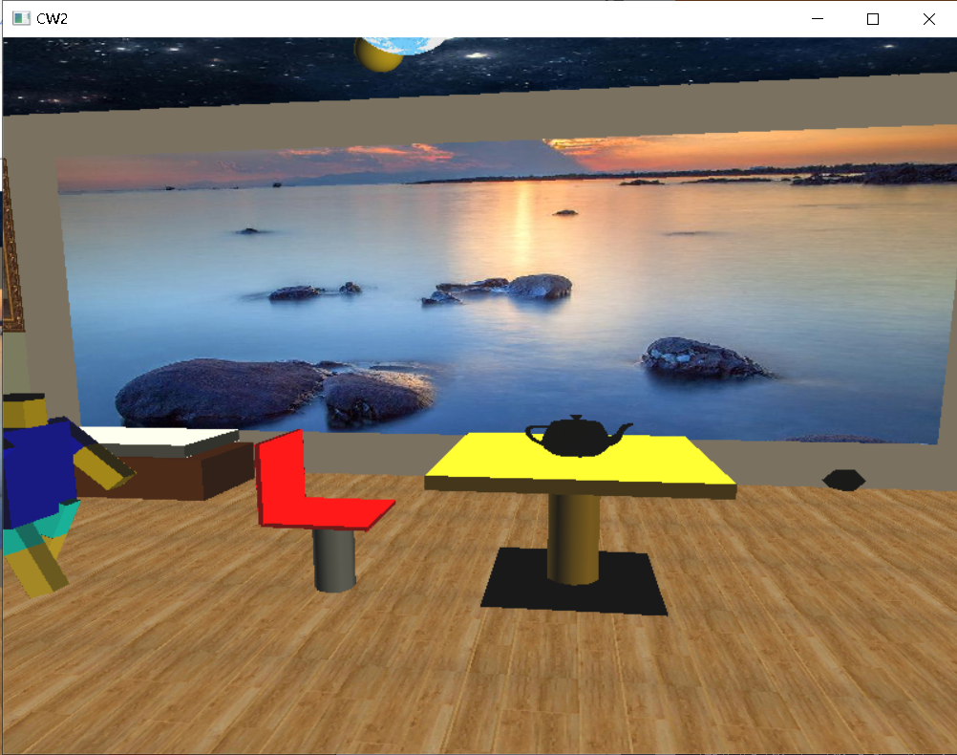

press e or E press o or O（zooming teapot）

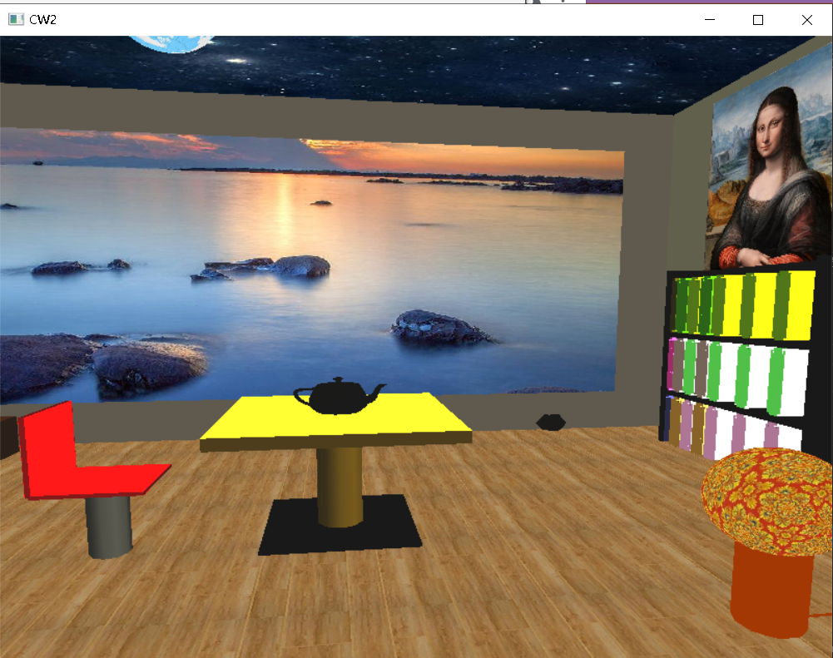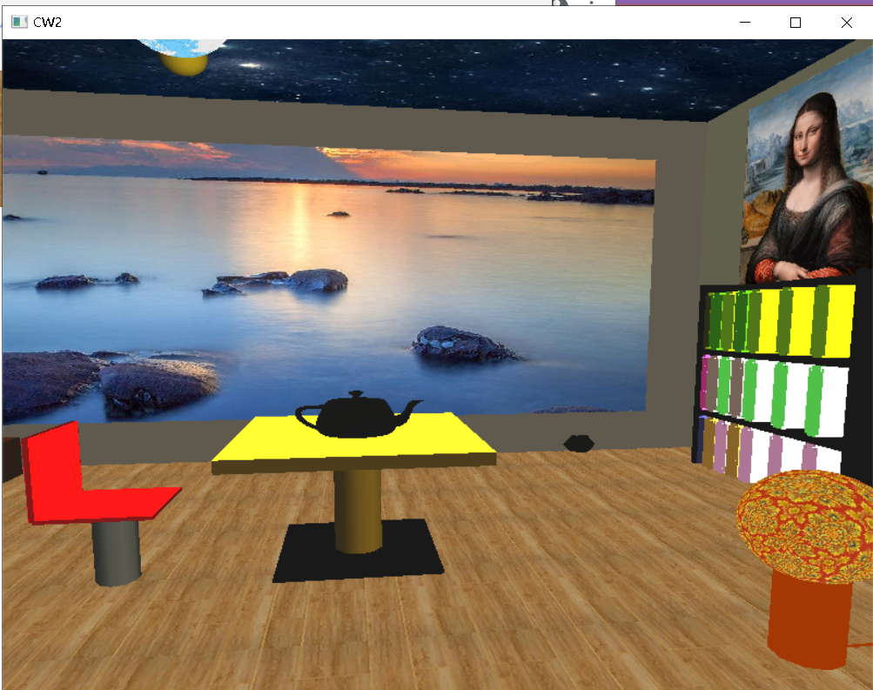

press v or V (rotate chair) press t or T(stop robot )

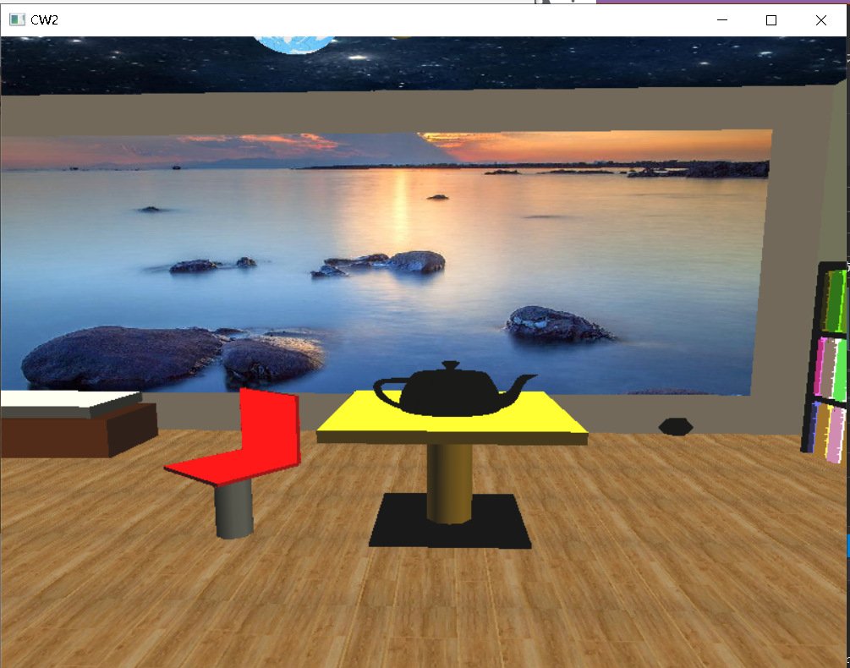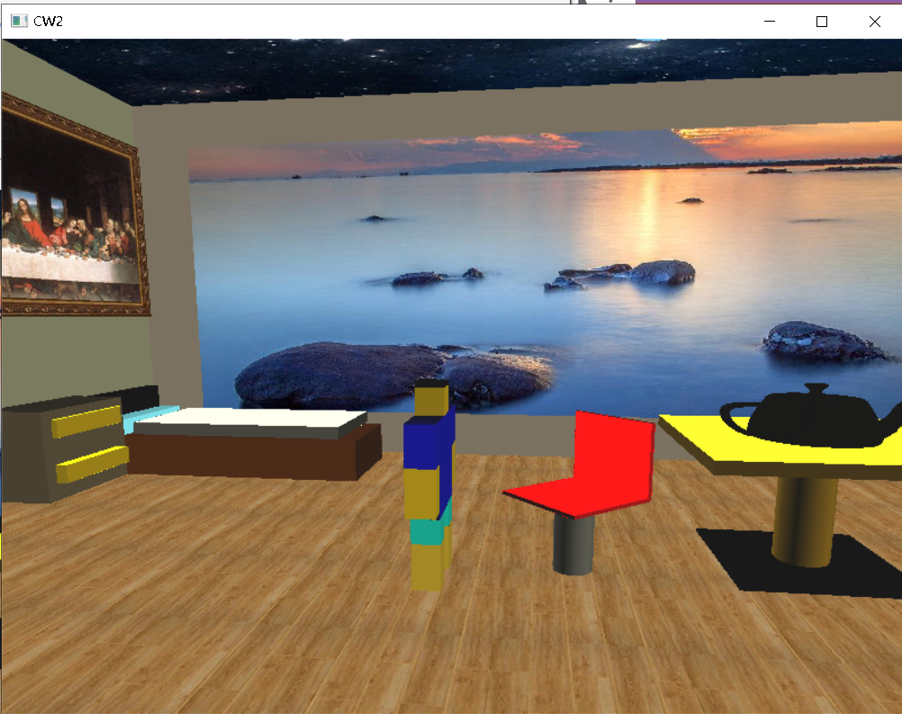

press h or H（open drawer ）

